Fitness calculator

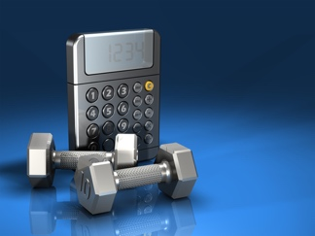

Image source link: <http://www.getfitwow.com/fitness-calculator.html#.WJzd9rZ95E4>

Video link: <https://youtu.be/85j1vIOOpLo>

A user can input the number of reps/minutes in the number field. Then he can select the type of exercise from the list below. The input metrics (reps or minutes) will change automatically corresponding to the type of exercise the user chooses. As soon as the the user click the “Convert” button, the amount of calories will be calculated and shown in the output field on the top of the right side. The user can also choose a type of exercise to see the equivalent amount of reps/minutes of that type of exercise to reach the same amount of calories. The output will be shown in the field below the field of amount of calories. The output metrics will also change automatically corresponding to the type of exercise the user chooses.

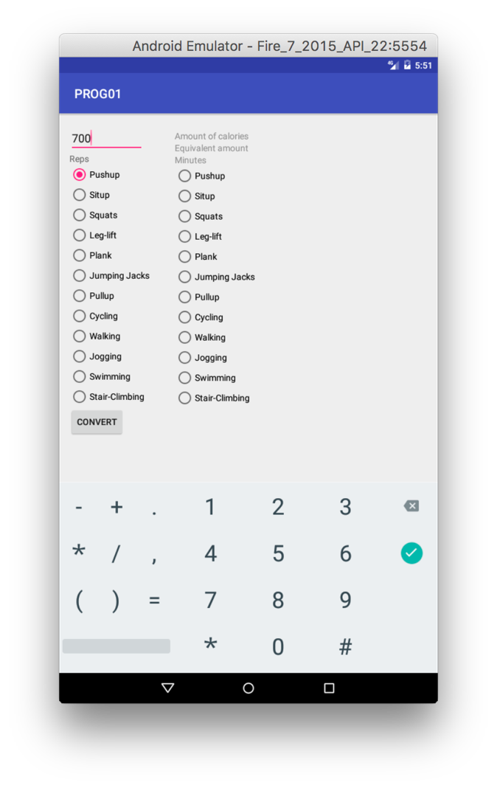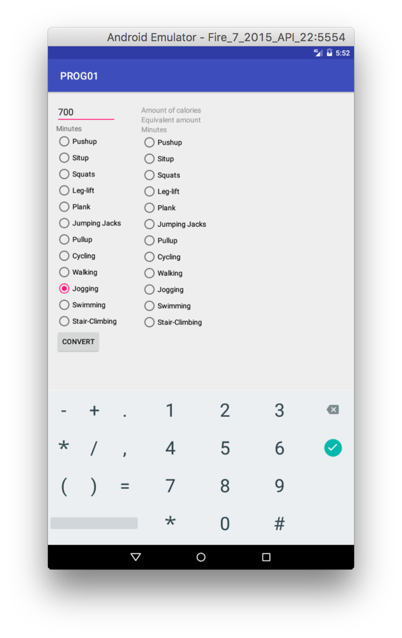

Input number of reps/minutes Metrics change corresponding to users’ choice

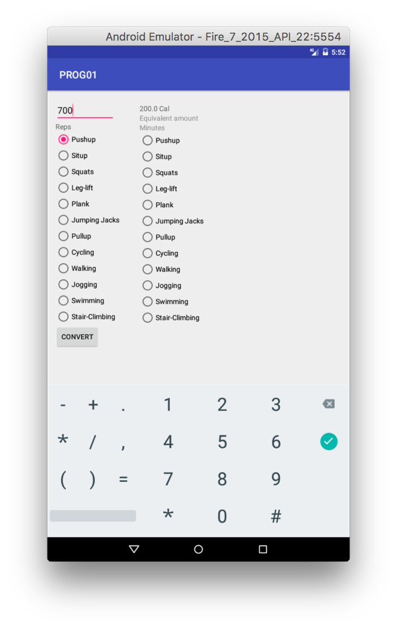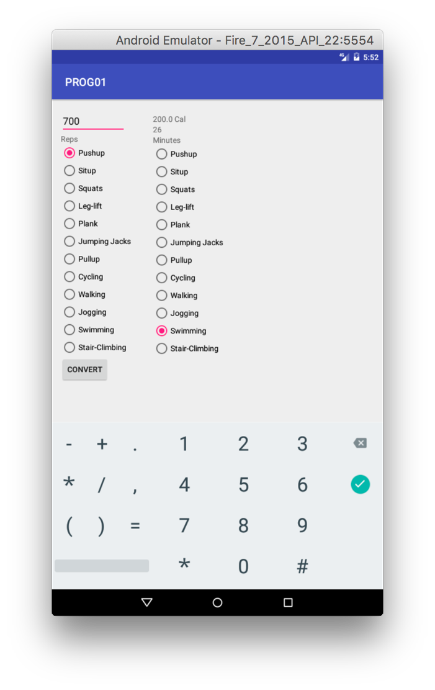

Show the amount of calories Equivalent amount of another type of exercise